ROCK PAPER CHISELS
‘LUING FROM THE SEA’ BOAT TRIPS
Saturday 21st Sept 10.00am-12.00pm or Sunday 22nd Sept 10.00am-12pm.
See and discover Luing’s fascinating history from on board the ‘Golden Eye’. If the weather is good, we’ll go all the way round Luing and Torsa. If not, we’ll keep to the east. Both routes have great views and interesting sites to see, introduced to you by island historian and archaeologist Mary Braithwaite. The trips are run by Luing-based business ‘Wild Island Experience’.
Price: £75 per person. Places are limited to a maximum of eleven people on each of the two trips, and must be booked and paid in advance. Book and pay by phoning 01852 314 096 or visiting the Atlantic Islands Centre between 10am and 12 noon from Wednesday 4th to Sunday 8th Sept or Wednesday 11th to Sunday 15th Sept (the Centre is closed on Mondays and Tuesdays).
A minimum of 6 bookings per trip is needed to cover the costs; if less than 6 we reserve the right to cancel the trip and, if places allow, offer to transfer the booking to the other trip. If this is not possible, we will refund the cost.
If a passenger books a place and later cancels it after 15th September, a refund will be given only if we can fill the place or if the trip has to be cancelled, for example due to bad weather.
In the event of adverse weather, the trips may need to be cancelled at the last minute. The skipper has sole discretion to decide the route of the trip and if a trip needs to be cancelled for your safety. In this situation full refunds will be made.
Passengers can be picked up from north or south Cuan, ie on the Seil or Luing ferry piers. Please indicate this when you book.
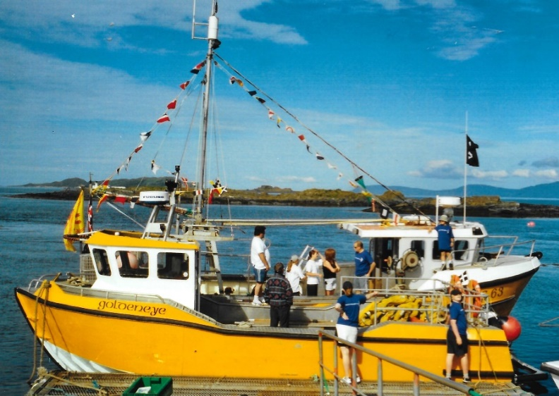
People joining the boat trips will need to be agile enough to step from the pier onto the boat and then down into the boat. Warm and waterproof clothing and sensible shoes will be needed. Lifejackets will be provided. There are safe bench seats but no inside cabin on the boat. There are no toilets on the boat.
The ‘Golden Eye’ is an open-deck boat owned by 'Wild Island Experience', an island business run by Luing residents Becks & Ninian. ‘Wild Island Experience’ has a remote island retreat space on the neighbouring island of Lunga, which can be used for fully-catered/self-catered holidays, business collaborations and retreats. For more info email wildislandexperience@gmail.com

